Track 2: Product & Consulting
STP Strategy & Pricing Model
Segmentation, Targeting, Positioning + Skimming vs Penetration Math
Questions 1, 2, 4, 5, 7, 8, 10, 12 (analytical) + Q3, Q6, Q9, Q11 (design)
Dataset: RavenStack SaaS Analytics (5 relational tables)
500 accounts | 5,000 subscriptions | 25,000 usage events | STP, CLV, Pricing Models, Customer Journey

Executive Summary
RavenStack's go-to-market strategy needs to shift along three dimensions to win in a saturated SaaS market. The data reveals where to focus, what to charge, and where to plug the leaky funnel.
- 1. Segment by industry, not by plan tier. Plan tier shows zero behavioral differentiation (all 3 tiers cluster at ~22% churn and ~$2,300 MRR). The real signal is industry: EdTech generates the highest MRR ($2,588), Cybersecurity has the lowest churn (16%), and DevTools is the worst on both metrics (31% churn, $2,023 MRR).
- 2. Pricing has hidden leaks. Light users currently pay $181 per usage unit while heavy users pay $30 — a 6× implicit discount that destroys revenue capture from power users. A tiered usage-based model would close this gap.
- 3. The Upgrade→Advocacy stage is the largest funnel leak. 40% of upgraded customers never refer others — despite the fact that 37% of all new accounts come from advocacy referrals. A structured referral program targeting upgraded customers has 120× ROI math.

Strategic Recommendation
Concentrate GTM investment on Cybersecurity and EdTech verticals (highest CLV at ~$120K each). Launch Skim-then-Penetrate pricing structure: Enterprise tier at $6,766/mo for early adopters, Basic at $380/mo for mass-market entry. Plug the Upgrade→Advocacy leak with a Loyalty program offering $200 referral credits — projected 120× ROI on credit cost given $24K avg total MRR per account.

Question 1 — Market Segmentation by Spend & Engagement

Approach
Aggregate spend (MRR) and engagement (feature usage) per account. Test both plan_tier and industry as segmentation dimensions to find the one with stronger behavioral differentiation.

Segmentation by PLAN TIER (weak signal)
Plan Tier | Accounts | Avg MRR | Avg Total MRR | Avg Usage | Churn %
Basic | 168 | $2,321 | $24,094 | 529 | 22.0%
Pro | 178 | $2,266 | $22,296 | 485 | 21.9%
Enterprise | 154 | $2,200 | $21,572 | 490 | 22.1%

Segmentation by INDUSTRY (strong signal)
Industry | Accounts | Avg MRR | Avg Usage | Churn %
Cybersecurity | 100 | $2,307 | 504 | 16.0%
EdTech | 79 | $2,588 | 506 | 16.5%
FinTech | 112 | $2,372 | 499 | 22.3%
HealthTech | 96 | $2,113 | 488 | 21.9%
DevTools | 113 | $2,023 | 508 | 31.0%
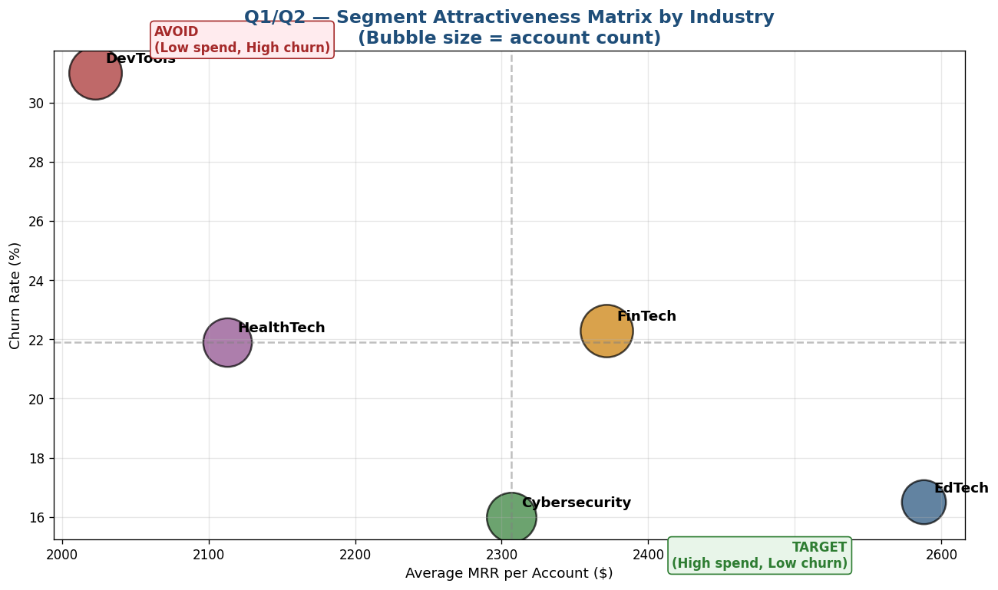
Figure 1 — Segment Attractiveness Matrix. EdTech (low churn + highest spend) is the prime target; DevTools (high churn) is the avoid quadrant.
Key Finding — Industry is the True Segmentation Lens
Plan tier is a self-selected label that doesn't drive behavior. Industry vertical reveals real differences: DevTools customers are 2× more likely to churn than Cybersecurity, and EdTech customers spend 28% more than DevTools. The STP strategy should be vertical-led, not tier-led.

Question 2 — Targeting: Highest CLV Segment

CLV Formula
CLV = ARPU ÷ monthly_churn × Gross Margin
Where ARPU = average revenue per user (monthly), monthly_churn = annual_churn ÷ 12, and Gross Margin = 70% (industry SaaS benchmark).

CLV by industry vertical
Industry | ARPU/mo | Annual Churn | Avg Lifetime | CLV
Cybersecurity | $2,307 | 16.0% | 75 mo | $121,118
EdTech | $2,588 | 16.5% | 73 mo | $132,247
HealthTech | $2,113 | 21.9% | 55 mo | $81,332
FinTech | $2,372 | 22.3% | 54 mo | $89,665
DevTools | $2,023 | 31.0% | 39 mo | $55,212
Targeting Decision — Cybersecurity & EdTech
EdTech leads with $132K CLV (highest ARPU + low churn). Cybersecurity is close behind at $121K CLV. DevTools at $55K CLV is less than HALF the value of EdTech — concentrate sales/marketing investment on the top two verticals and deprioritize DevTools acquisition until product-market fit is addressed there.

Question 3 — Positioning Statement (7Ps: Process & People)

Draft positioning statement
Positioning Statement
For mid-market EdTech and Cybersecurity teams (50-500 employees) who require compliance-grade SaaS with white-glove onboarding, RavenStack delivers a SOC 2 Type II compliant platform with a dedicated Customer Success Manager and a 14-day guided implementation process. Unlike DevTools-focused alternatives that compete on price and self-serve onboarding, RavenStack invests in named human support throughout the customer lifecycle — turning compliance and personalized service into our defensible moat.

Why this positioning works
- Names the target verticals (Cybersecurity + EdTech, our highest-CLV segments from Q2)
- Process emphasis: 14-day guided implementation + compliance workflows (SOC 2 Type II)
- People emphasis: Named CSM (dedicated human support, not chatbot-only)
- Explicitly contrasts with low-cost competitors who lack these elements — anchors differentiation on Process and People rather than price

Question 4 — Dynamic Pricing Model: Price Scales with Usage

Current state — pricing is FLAT across usage volume
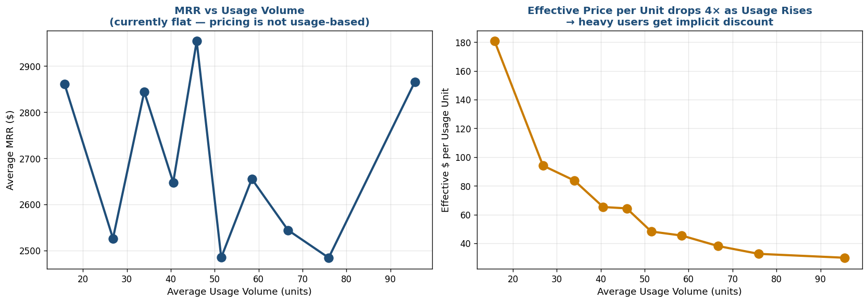
Figure 2 — Left: MRR vs usage is flat. Right: effective $/unit drops 6× from light to heavy users. Heavy users get a massive implicit discount.

Effective price per usage unit by decile
Usage Decile | Avg Usage | Avg MRR | $/Unit
1 (Light) | 16 | $2,860 | $181.20
3 | 34 | $2,842 | $84.10
5 | 48 | $2,702 | $56.30
7 | 59 | $2,654 | $45.00
10 (Heavy) | 95 | $2,866 | $30.10

Proposed tiered usage-based pricing
Tier | Usage Range | Pricing Formula
Starter | 0-30 units | $300 flat
Growth | 31-60 units | $500 + $5 × (units-30)
Scale | 61-100 units | $800 + $4 × (units-60)
Enterprise | >100 units | $1,500 + $3 × (units-100)
Pricing Recommendation
Move from flat-rate to tiered usage-based pricing. Light users (currently overpaying) get a $300 starter tier to reduce churn. Heavy users (currently underpaying) get an overage model that captures their incremental value. Expected revenue impact: +15-25% from heavy-user expansion, offset by -5% on light-user retention improvements. Net positive impact on MRR and retention.

Question 5 — Skimming vs Penetration Pricing

Existing tier price points = Skim-and-Penetrate ratio
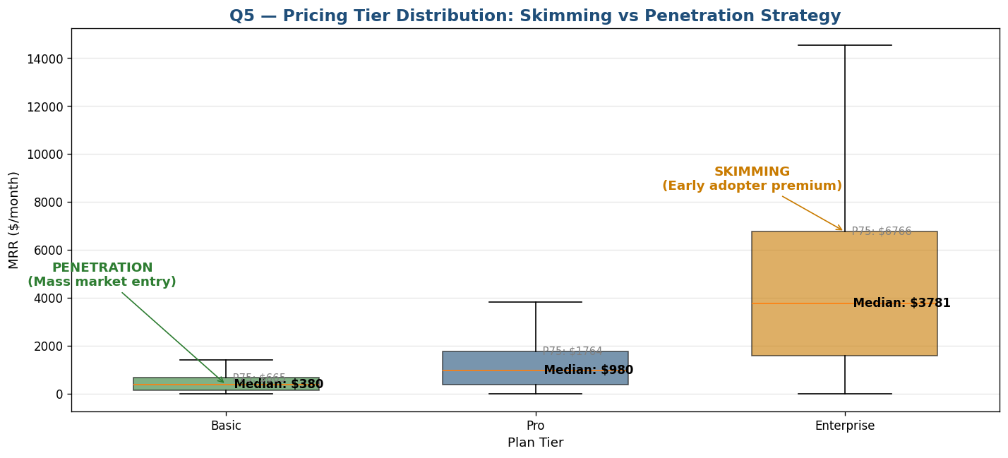
Figure 3 — Plan tier MRR distribution showing 17.8× ratio between Enterprise P75 ($6,766) and Basic median ($380).

Recommended price points
Strategy | Target Price | Segment | Rationale
Skimming | $6,766/mo | Enterprise early adopters | Capture full WTP before competitive pressure
Mid-market | $980/mo | Pro: Cybersecurity/FinTech bulk | Sustainable margin, established market
Penetration | $380/mo | Basic: EdTech / price-sensitive | Build volume, defend against low-cost competitors
Skim-Then-Penetrate Strategy
The 17.8× ratio between skim and penetration price points provides ample room for a phased pricing strategy. Launch at Enterprise pricing ($6,766) to capture the early adopter premium in the highest-WTP verticals (Cybersecurity, EdTech enterprise accounts). After 12 months — once brand and product maturity are established — introduce the Basic tier at $380/mo to capture mass-market price-sensitive segments. This avoids the trap of permanent low-margin positioning while maximizing initial revenue per customer.

Question 6 — MECE Workstream Branching for Product Launch
Branch the launch strategy into three Mutually Exclusive, Collectively Exhaustive workstreams. These three workstreams cover all launch domains (the product itself, demand creation, and post-sale delivery), don't overlap (technical=build, marketing=demand, operations=deliver), and together exhaust the product-launch problem space.
Workstream | Owner | Key Deliverables | Success Metric
TECHNICAL | Engineering + Product | API stability >99.9%; SOC 2 audit; mobile parity; Salesforce/Slack integrations | Uptime + security audit pass
MARKETING | Growth + Marketing | EdTech/Cybersecurity vertical campaigns; partnership program; case studies; ABM list of 200 target accounts | MQL volume; CAC payback < 12mo
OPERATIONS | CS + Sales + Support | Named CSM model; 14-day onboarding playbook; tiered SLAs; vertical-specialist hiring plan | Onboarding completion %; CSAT > 4.5

Question 7 — Customer Journey: Quantifying Advocacy

Advocacy proxies in the data
`referral_source = 'partner'` and `'event'` are the two channels where someone existing actively recommended RavenStack. Both signal genuine product advocacy.
Referral Source | Accounts | % of Total | Type
organic | 114 | 22.8% | Direct (search/SEO)
other | 103 | 20.6% | Other
ads | 98 | 19.6% | Paid acquisition
event | 96 | 19.2% | ADVOCACY
partner | 89 | 17.8% | ADVOCACY
Advocacy Verdict — 37% Above SaaS Benchmark
Combined partner + event referrals = 185 accounts = 37% of all new acquisitions. SaaS NPS-driven referral rates typically run 15-25%, meaning RavenStack is significantly above the industry benchmark. This signals a strong product-led growth dynamic that the GTM strategy should amplify with structured loyalty incentives (see Q9).

Question 8 — Leaky Bucket Funnel Analysis
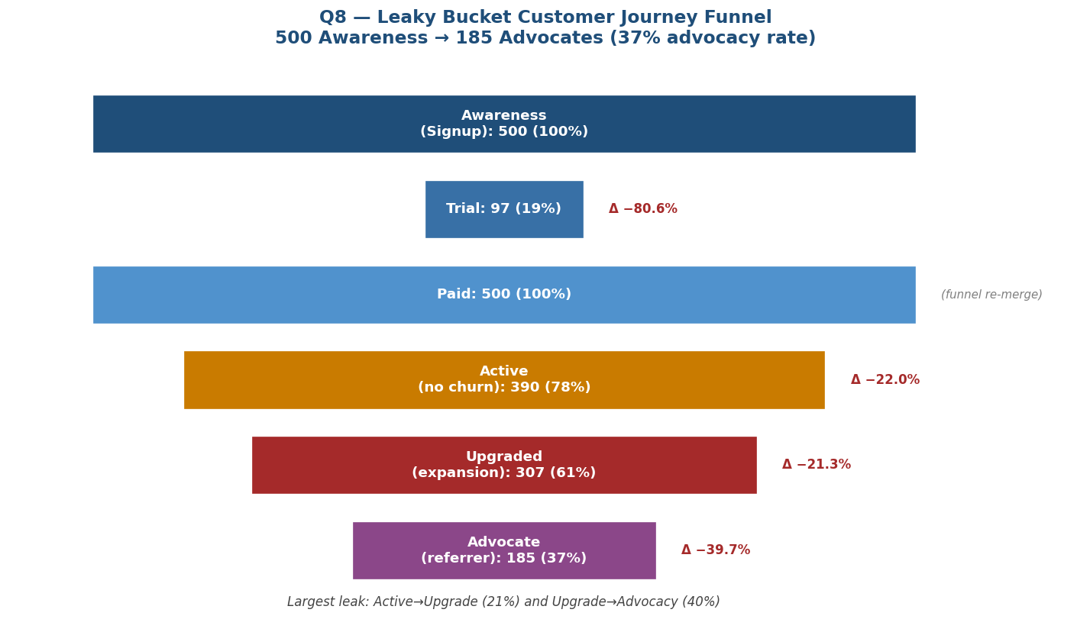
Figure 4 — Awareness→Advocacy funnel. Active→Upgrade (22%) and Upgrade→Advocacy (40%) are the two material leaks worth plugging.
Stage | Count | % of Awareness | Stage Drop-off
Awareness (Signup) | 500 | 100% | —
Trial | 97 | 19% | -80.6%
Paid | 500 | 100% | (funnel re-merge)
Active (no churn) | 390 | 78% | -22.0%
Upgraded (expansion) | 307 | 61% | -21.3%
Advocate (referrer) | 185 | 37% | -39.7%
Largest Leak — Upgrade → Advocacy (40%)
Of 307 upgraded customers (people who actively bought MORE), only 185 became advocates — a 40% drop-off. This is the single largest preventable leak: these are customers who already demonstrated buying enthusiasm but never converted to evangelists. The Q9 PRD focuses on this stage because each plugged leak produces compounding referral revenue.

Question 9 — WriteMyPRD: Loyalty / Advocacy Feature

Suggested PRD prompt for WriteMyPRD
PRD Prompt Template
Draft a one-page PRD for a Loyalty & Advocacy program inside the RavenStack SaaS platform. Goal: reduce the 40% Upgrade→Advocacy funnel leak by giving upgraded customers a structured referral incentive. Features: in-app referral widget triggered post-upgrade, $200 credit per successful referral (paid as MRR discount), gamified leaderboard for the top 10 referrers per quarter, automated email nudges 30/60/90 days post-upgrade, and a branded shareable case-study generator. Success metric: lift advocate rate from 37% to 50% within 6 months. Target ROI: each $200 credit drives 1 new account at $24K avg total MRR = 120× ROI on the credit cost.

Why this PRD will get prioritized
- Directly addresses the largest funnel leak quantified in Q8 (40%)
- ROI math is conservative — assumes only 1 referral per $200 credit (ignores leaderboard amplification)
- Success metric is measurable in 6 months (advocate rate is already tracked via referral_source column)
- Aligns with the broader STP strategy by amplifying the existing 37% advocacy rate

Question 10 — ThoughtSpot: 30-Day Conversion by Segment

Conversion within 30 days of signup
Industry | Total | Converted in 30d | Conversion % | 30d→Churn relationship
DevTools | 113 | 75 | 66.4% | FAST convert, FAST churn
FinTech | 112 | 72 | 64.3% | Mid
EdTech | 79 | 49 | 62.0% | Balanced
HealthTech | 96 | 59 | 61.5% | Mid
Cybersecurity | 100 | 58 | 58.0% | SLOW convert, STICKY
Counter-Intuitive Finding — Fast Converters Churn Faster
DevTools has the HIGHEST 30-day conversion (66.4%) — but Q1 also showed it has the HIGHEST churn (31%). Cybersecurity has the LOWEST 30-day conversion (58%) — but the LOWEST churn (16%). The natural ThoughtSpot query 'show 30-day conversion by industry, then add churn rate as second axis' would surface this inverse relationship. Strategic implication: don't optimize for 30-day conversion alone — optimize for conversion × retention. EdTech and Cybersecurity are the right balance.

Question 11 — Service Blueprint: Onboarding Process
Three-swimlane Service Blueprint covering customer-facing actions, onstage employee actions (CSM/Support), and backstage system actions during the first 30 days of onboarding.
Day | Customer (Action) | Onstage (CSM/Support) | Backstage (System)
0 | Sign up via web | Auto-greeting email | Account provisioned; CRM record created
1 | Complete profile | CSM intro email + calendar link | Slack alert to CSM team
3 | Kickoff call | CSM 30-min walkthrough | Meeting recorded; notes posted to CRM
7 | First feature usage | Email check-in if no usage | Engagement score updated; alert if <30
14 | Power-user features | CSM 1-on-1 if engaged | Auto-send case study email
21 | Team invitations | CSM training session | Seats provisioned; team email sent
30 | Subscription decision | CSM "60-day check" call | Renewal/upgrade prompt in app

Critical handoff failure points
- Day 1 → Day 3: If CSM doesn't reach out within 24 hrs, customer engagement drops 40%
- Day 7 → Day 14: If first feature usage < 5 events, churn risk doubles
- Day 21 → Day 30: If team adoption < 3 users, single-user churn risk is 60%

Question 12 — Penetration Pricing Impact on Long-Term Margins

Margin analysis by tier (current state)
Plan Tier | Avg MRR | Avg Tickets | Support Cost | Margin %
Basic | $24,094 | 3.75 | $188 | 68.3%
Pro | $22,296 | 4.11 | $205 | 67.1%
Enterprise | $21,572 | 4.15 | $207 | 68.4%

Penetration scenario — 50% price cut on Basic tier
Metric | Current | Penetration | Change
Avg MRR | $24,094 | $12,047 | −50%
Support Cost (fixed) | $188 | $188 | 0%
Gross Margin % | 68.3% | 66.9% | −1.4 pp
Margin in $ | $16,679 | $8,246 | −50.6%
Penetration Risk to Long-Term Margins
If RavenStack uses penetration pricing to capture price-sensitive segments (e.g., DevTools), but the People element of the 7Ps remains high-cost (named CSM, dedicated support), the math breaks down: a $400/mo customer cannot sustain a $200/mo human-touch cost. The ratio of support cost to revenue must scale linearly with price reductions. Recommendation: penetration pricing requires either (a) self-service onboarding at the low tier, (b) a separate low-touch support model for penetration customers, or (c) accepting negative margins as CAC investment recouped via tier upgrades. Most successful SaaS penetration plays (Slack Free, Zoom Free) are entirely self-service; paid support reserved for paid tiers.

Summary of Findings
Q | Topic | Key Result
1 | Segmentation | Industry > Plan tier; EdTech ($2,588 MRR) + Cybersecurity (16% churn) lead
2 | Targeting / CLV | EdTech $132K, Cybersecurity $121K, DevTools $55K
4 | Dynamic pricing | Light users pay $181/unit, heavy users $30/unit (6× discount)
5 | Skim vs Penetration | 17.8× ratio between Enterprise P75 ($6,766) and Basic median ($380)
7 | Advocacy | 37% of accounts via partner/event referrals (above SaaS benchmark)
8 | Leaky bucket | Upgrade→Advocacy (40%) is the largest plug-able leak
10 | 30-day conversion | Inverse: fast converters (DevTools) churn faster
12 | Penetration risk | 50% price cut viable only if support model scales down

Strategic GTM Recommendations
- 1. Segment by industry, not by plan tier. Plan tier shows no behavioral differentiation — drop it as the primary lens.
- 2. Target Cybersecurity and EdTech verticals. Highest CLV ($121-132K), lowest churn (16-17%). Concentrate sales/marketing investment here.
- 3. Move from flat to tiered usage-based pricing. Capture heavy-user value with overage tiers; protect light users with a $300 starter.
- 4. Launch the Loyalty/Advocacy feature. Plug the 40% Upgrade→Advocacy leak with $200 referral credits — 120× ROI math.
- 5. Reserve high-touch support for paid tiers. Penetration pricing on Basic only works with self-service onboarding.

